GIT BRANCHING AND GITHIB (How to pull BRANCH FROM GITHIB REPO)

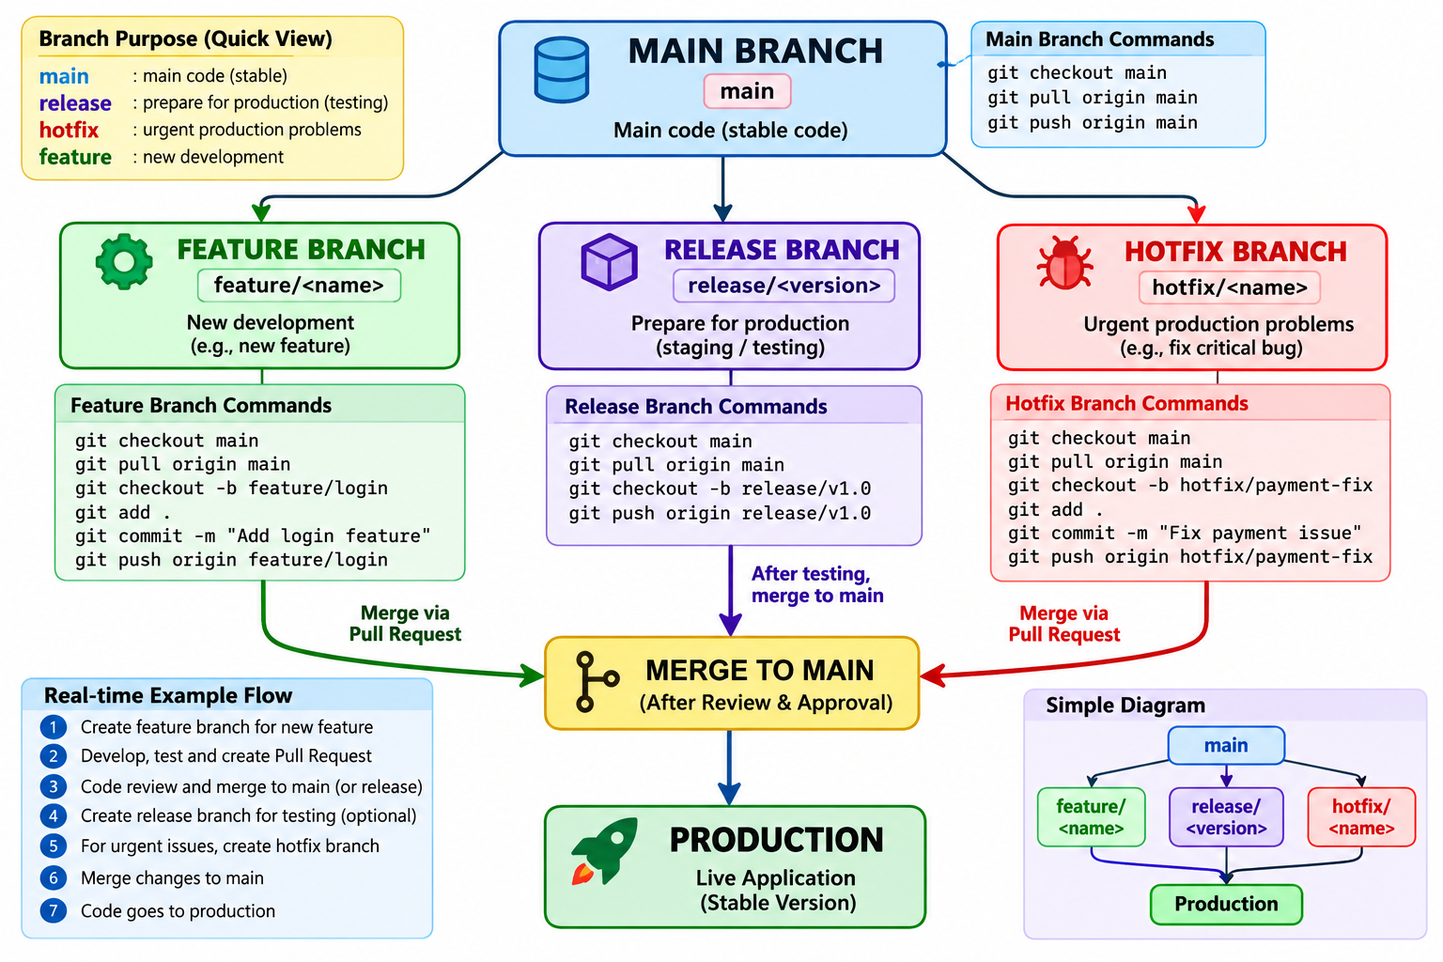

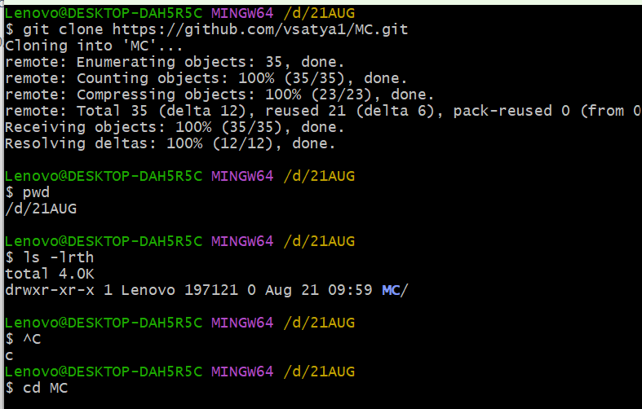
SETP 2:- MAIN BRANCH OUTPUT
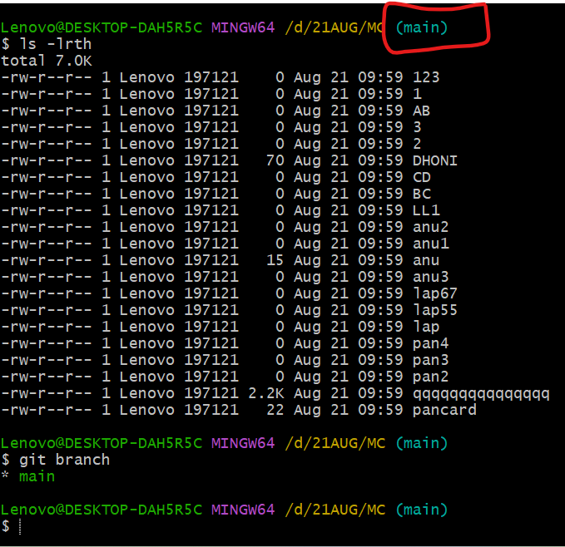
SETP 3:- create new branch ( fetature_audio call 1 I will create ) shortcut name is fet_ac1
Git checkout fet_ac1 ( this command is used go to another branch
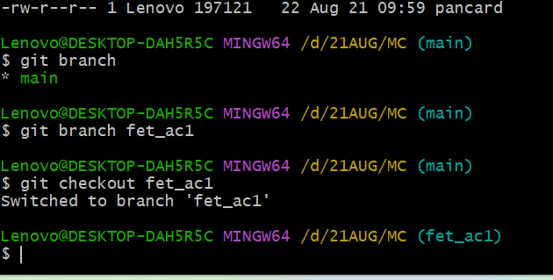
SETP 4:- to see below output same files are available main branch fet_ac1 please find the below output
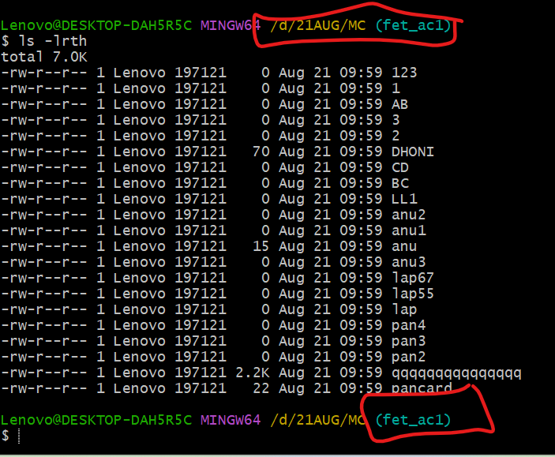
Below command how files are there main branch and fet_ac1
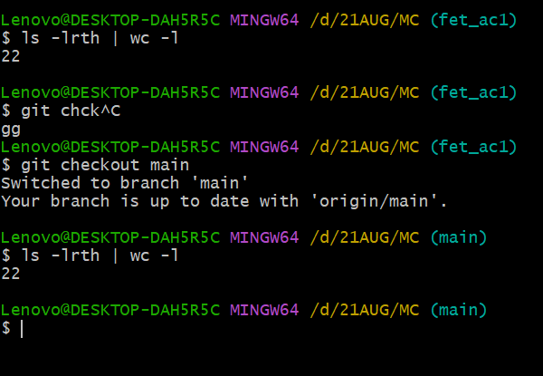

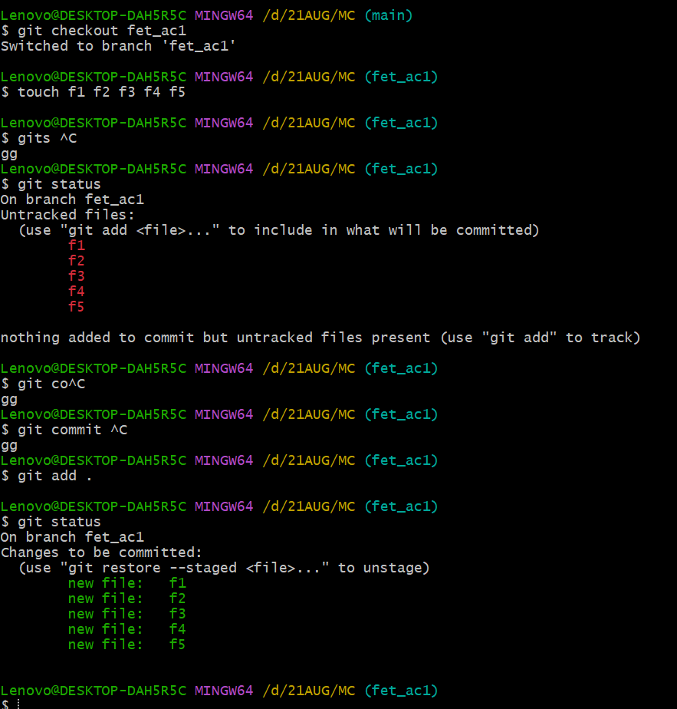

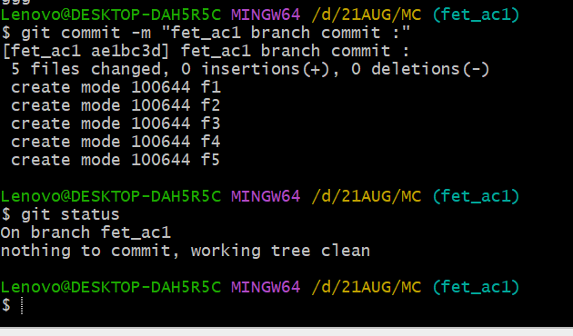
See blow output fet_ac1 and main branch files are available
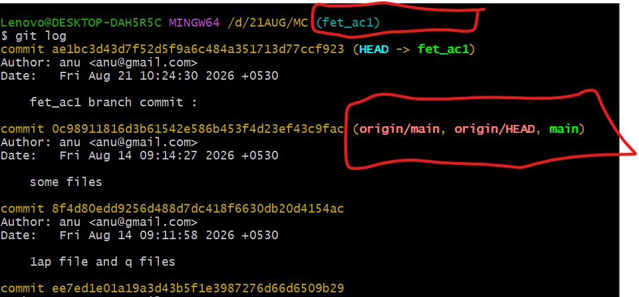

Below output fet_ac1 27 files are there , But Main branch only 22 file are there
Fet_ac1 branch
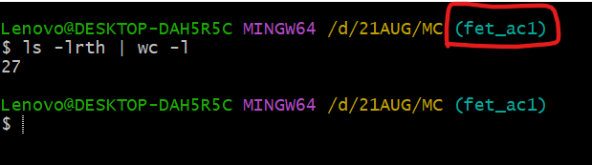
Now logout main branch how many file are there
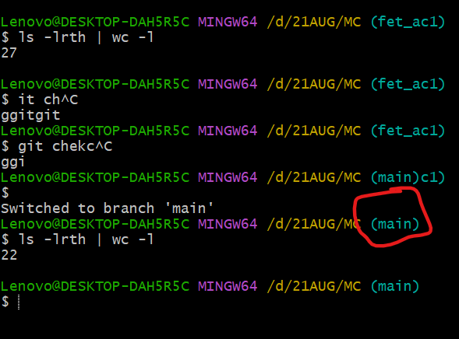

Fet_ac1 branch to push git hib reposi ( it means to create new branch central repo)

This command is used fet_ac1 branch to pull centro repo
git push https://github.com/vsatya1/MC.git fet_ac1
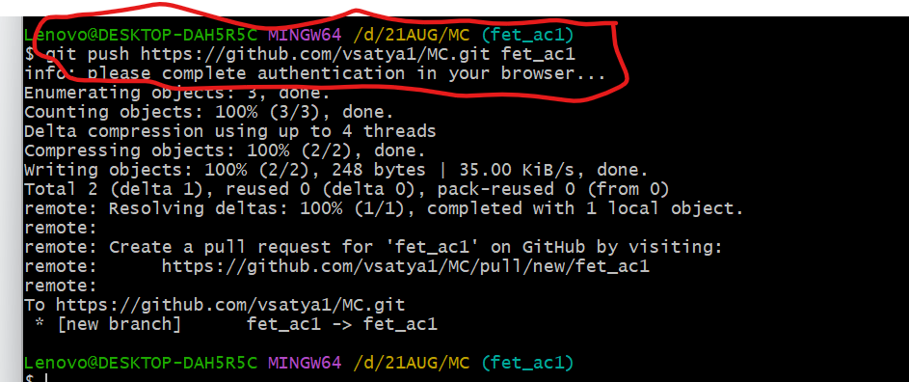

GITHUB REPOSITORY OUTPUT :-
Please take one task
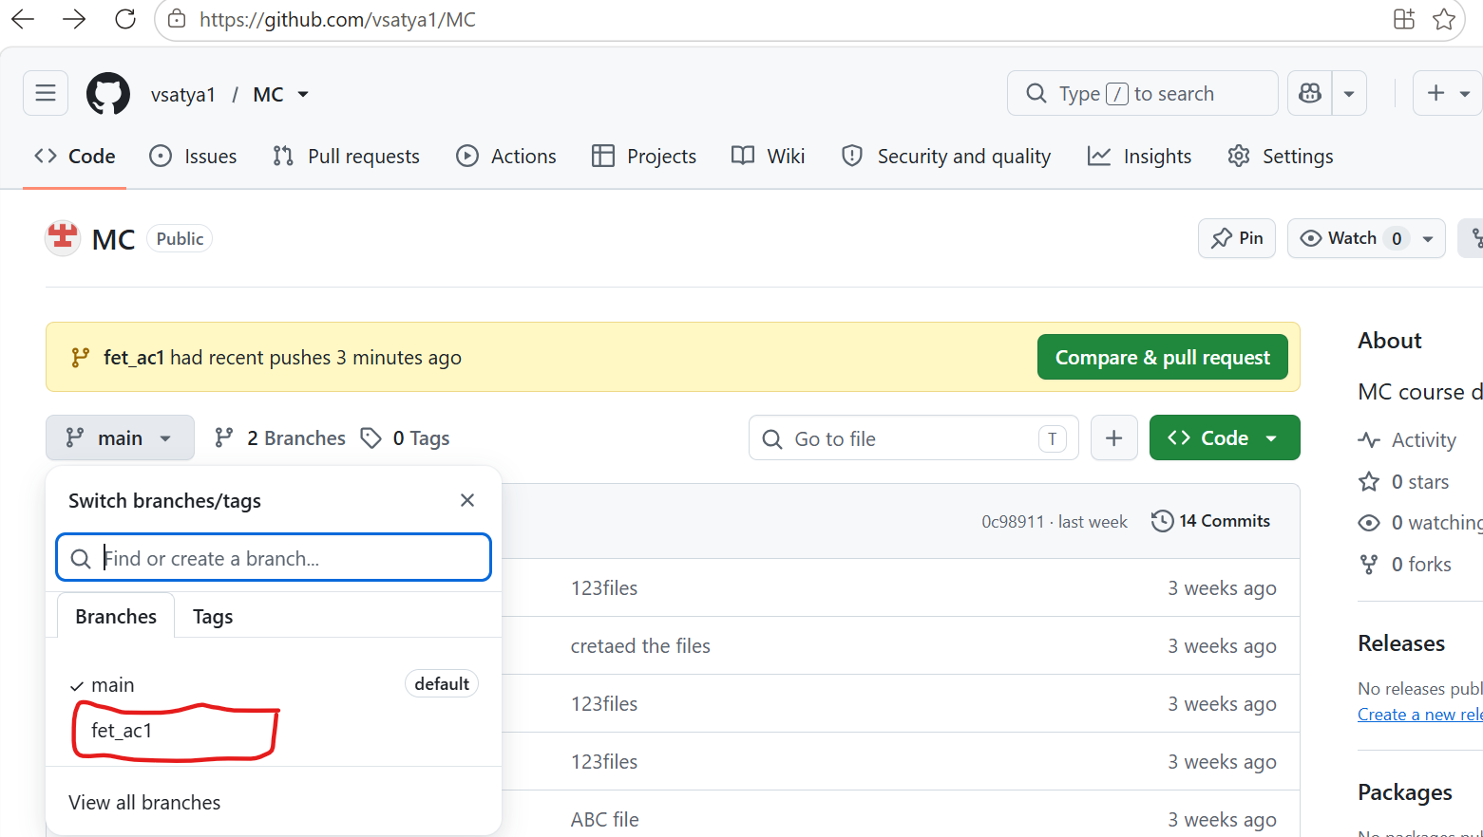

How to merge two branches:-

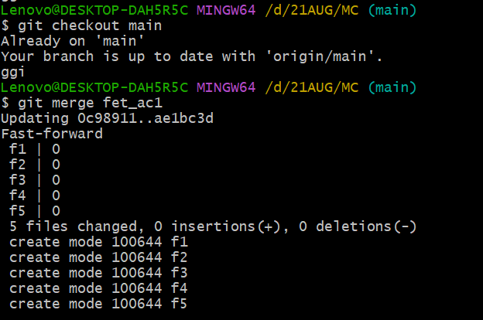
How to check log command is git log :-
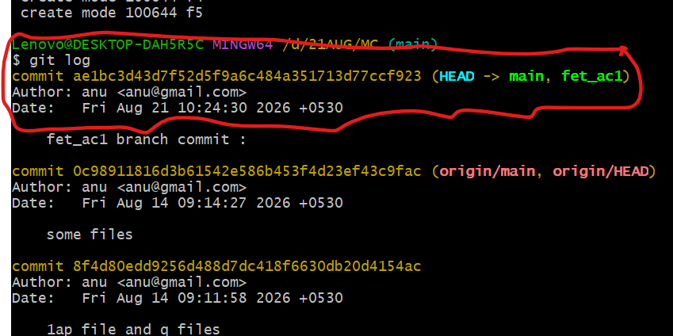

how to check how many branches local
git branch
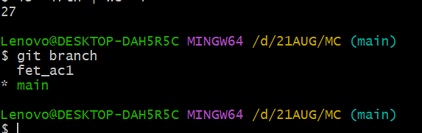

GIT PUSH ORIGIN (where is use ORIGIN option how to change code level) HOT FIX BRANCH LEVEL AND FEATURE BRANCH LEVEL Below the examples :-

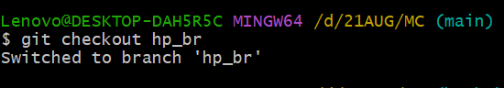

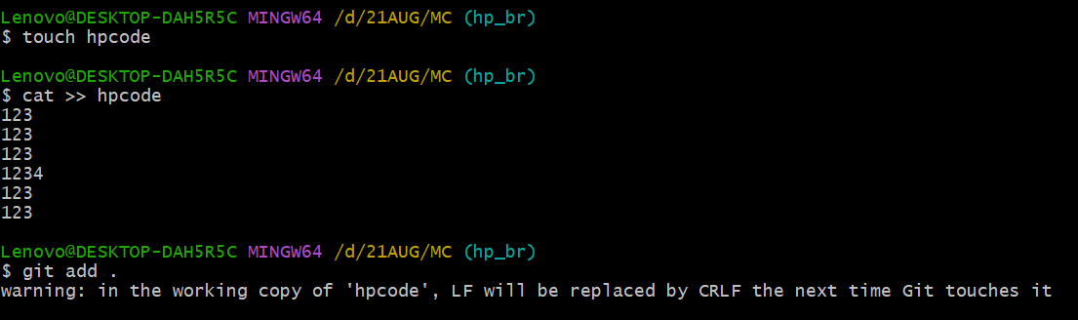

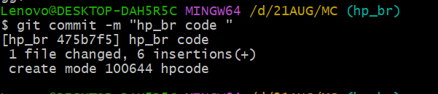

Below screen shot I am using origin command
You can below commands are same
1.git push origin hp_br or git push https://github.com/vsatya1/MC.git hp_br

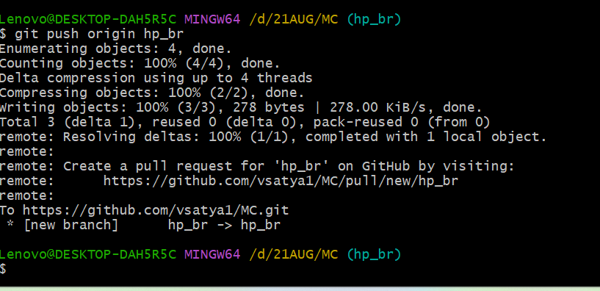
One it pushed centoizied repo branch it will show autumnally
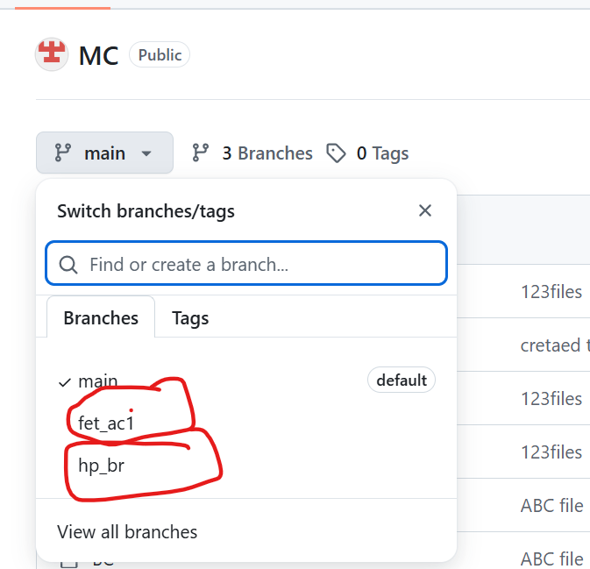

I am adding hp code file please find the below output from hp_br (hp_branch)

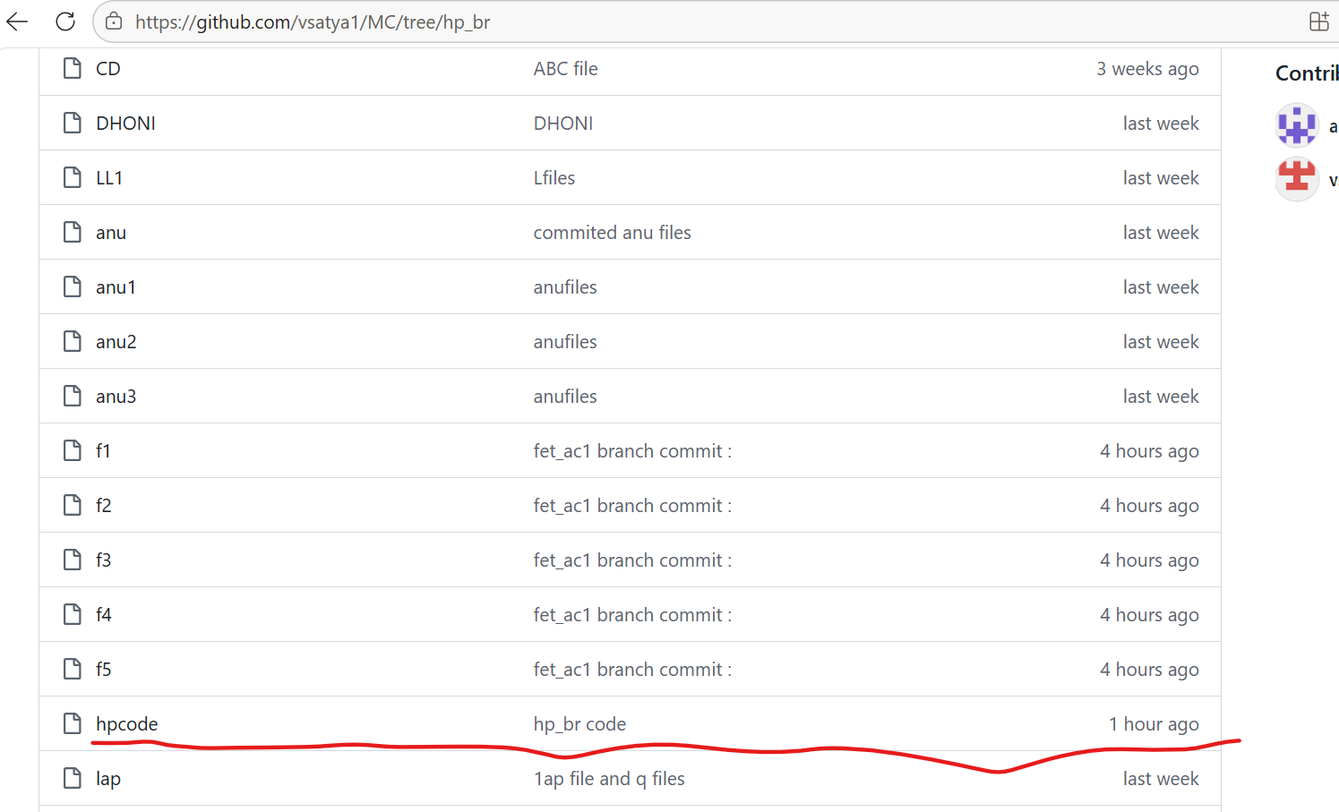

CHERRY PICK :- Take ONE specific commit from another branch and apply it to your current branch.
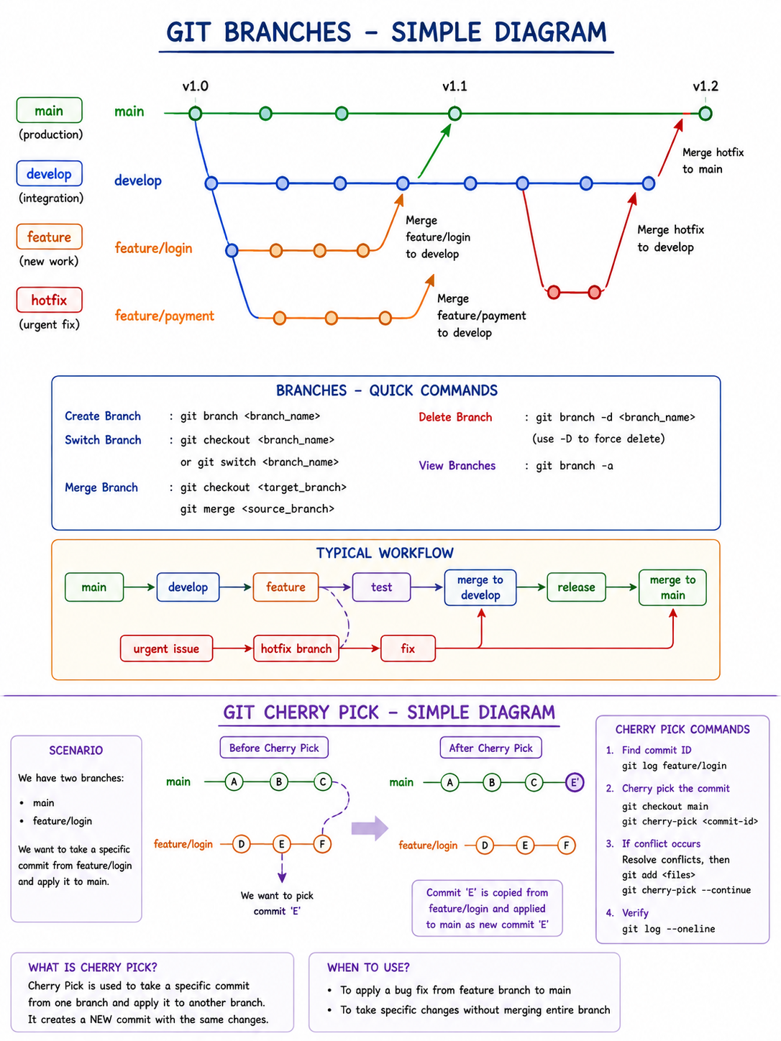

WE NEED PARTCISE LOCAL LAPTOP

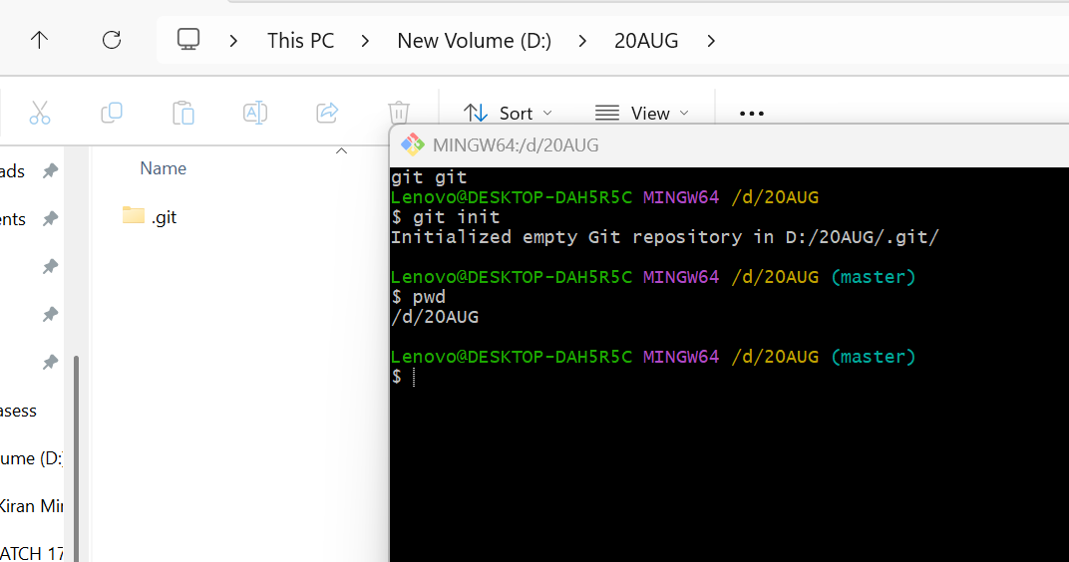
MASTER BRANCH FILES :-
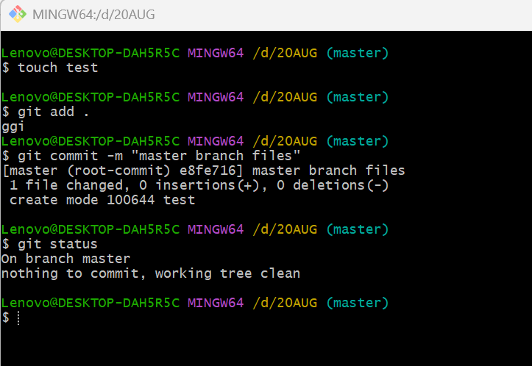
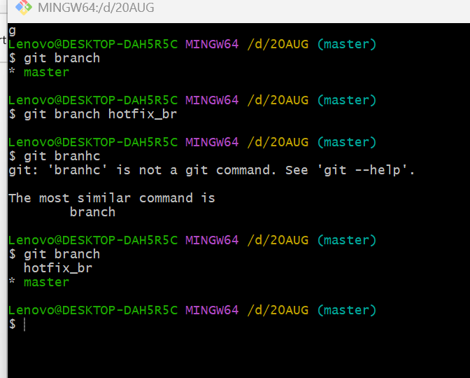

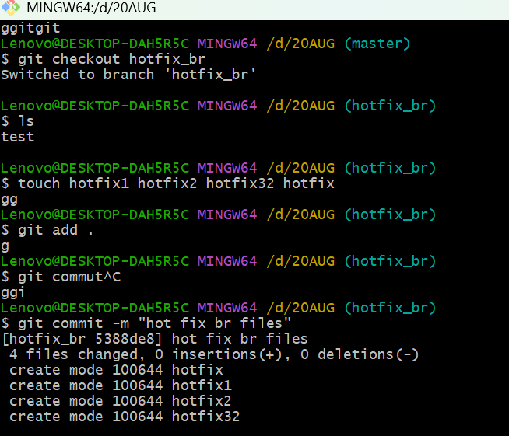
Hot fix branch files below output :-
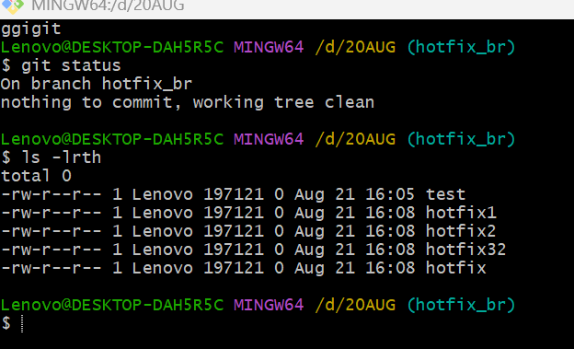
Master branch files :-
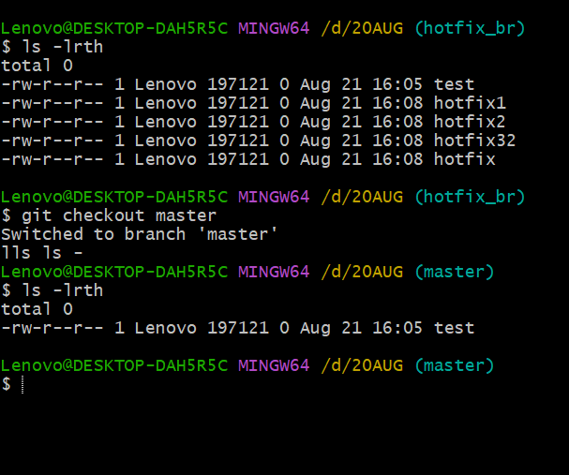

HOTFIX _BR files please find the below output
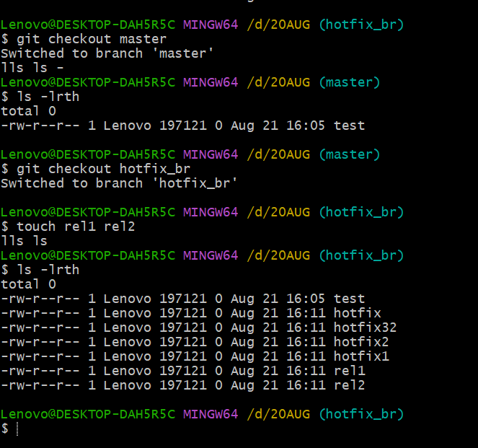
Take ONE specific commit from another branch and apply it to your current branch.
Git log output :-
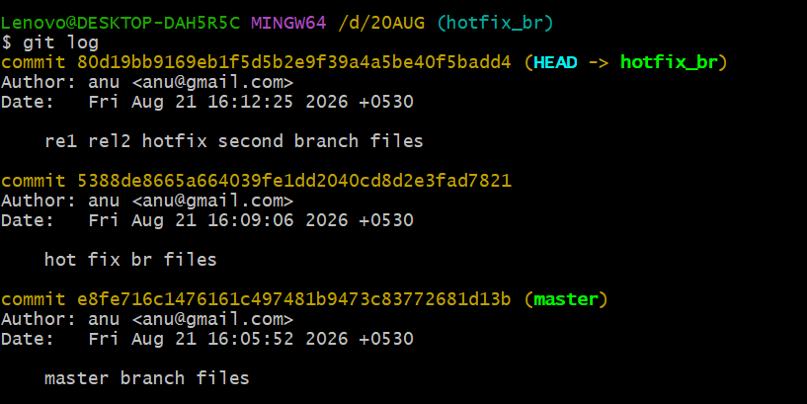
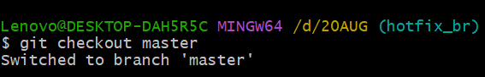
BEFORE OUTPUT :-
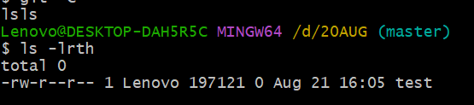
After apply cherry-pick command output :-
